**Literature Review**

Deepfake detection has become crucial due to the increasing use of generative adversarial networks (GANs) to create hyper-realistic fake videos and images. Researchers have explored various techniques, such as Convolutional Neural Networks (CNNs), Recurrent Neural Networks (RNNs), and hybrid models combining classical machine learning methods. These approaches primarily fall into two categories: spatial domain methods, which focus on image manipulation detection, and temporal domain methods, which analyse video sequences​.

A significant portion of recent research emphasizes the use of fusion methods that combine information from multiple modalities (e.g., audio and visual data) to improve detection accuracy. This has led to more robust detection frameworks that integrate data from multiple sources to identify inconsistencies indicative of deepfake manipulation. State-of-the-art machine learning models, such as Autoencoders and GAN-based architectures, are widely used for detecting spatial inconsistencies, while temporal methods like Long-Short Term Memory (LSTM) networks help in detecting fake content in videos​

<https://www.mdpi.com/2614282>

This paper presents a method for deepfake video detection using Recurrent Neural Networks (RNNs). The researchers explore temporal inconsistencies in videos, which deepfake generators often fail to replicate accurately. By focusing on sequential frame analysis, the method improves upon traditional approaches that primarily rely on spatial analysis of individual frames. This approach offers a robust detection technique that is less susceptible to the artifacts seen in some still-image-based detection methods

<https://ieeexplore.ieee.org/document/8639163>

Create an interactive "challenge" feature where users can test their ability to distinguish between real and deepfake content. This could be gamified to engage users while raising awareness of deepfakes.

Implement a community-based reporting system where users can flag potential deepfakes that they come across online. These flagged items can be used to improve the model and generate datasets for future research.

Include a section on the website that educates users about deepfakes, how they are created, and the ethical concerns around them. This could be in the form of blog posts, videos, or interactive tutorials.

**Introduction**

* Project Goal: Batch processing of videos for deepfake detection.
* Technologies Used: CNN, TensorFlow, Flask.

System Architecture

* Data Ingestion: Methods for collecting and storing images, videos, and audio.
* Preprocessing: Steps for cleaning and preparing data for model training.
* Model Training: Configuration and training of the CNN model using TensorFlow.
* User Interface: Design and implementation of the Flask-based web interface.

Component Design

* Data Ingestion:
  + Sources of data.
  + Storage solutions.
* Preprocessing:
  + Data cleaning techniques.
  + Data augmentation methods.
* Model Training:
  + CNN architecture.
  + Training parameters.
* User Interface:
  + Flask routes.
  + Frontend design.

Data Design

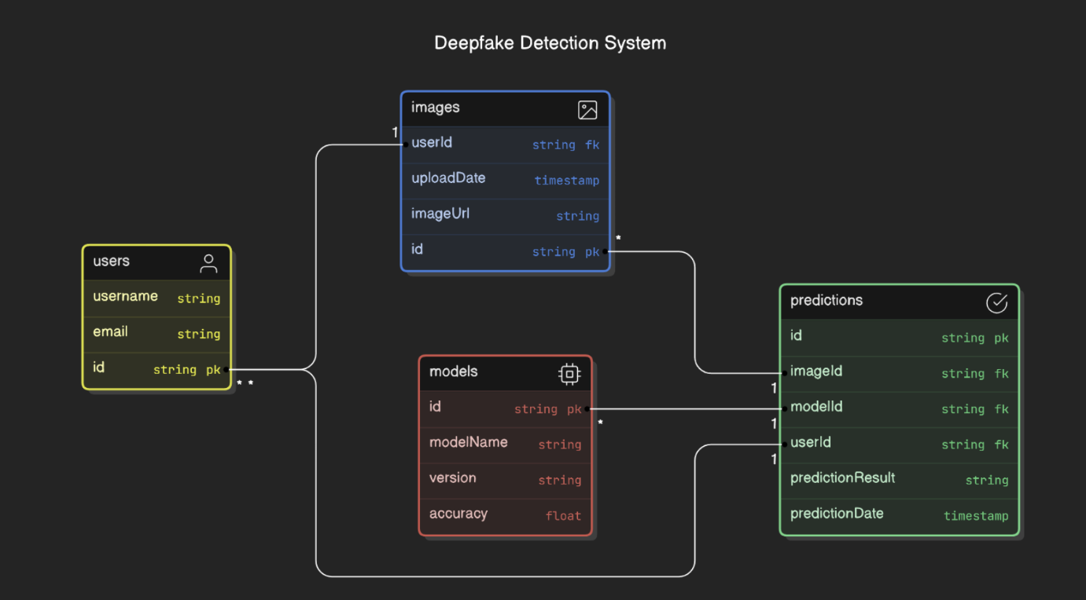

* ER Diagram: Representation of data entities and relationships

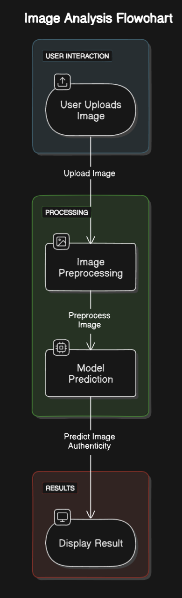

* Data Flow Diagram: Flow of data through the system.

Security Considerations

* Regular Security Audits: Schedule and scope of security audits.

Performance Metrics

* Accuracy: Measurement of correct predictions.
* Precision: Measurement of true positive rate.

Testing Strategy

* Unit Testing: Testing individual components.
* Security Testing: Ensuring system security.

Deployment Plan

* Cloud Environment: Steps for deploying the system on the cloud.

Maintenance and Support

* Guidelines: Procedures for maintaining and updating the system.

**1. Hardware Requirements:**

**Computing Resources:**

High-performance computing resources are imperative for training complex deep learning models efficiently. A machine with a powerful GPU (Graphics Processing Unit) is essential, as deep learning tasks benefit significantly from parallel processing capabilities. A GPU accelerates the training process, reducing the time required to achieve optimal model performance.

**Storage Capacity**

The project demands substantial storage capacity to accommodate the dataset, model checkpoints, and intermediate results generated during training. Adequate storage facilitates seamless data retrieval and manipulation, critical for preprocessing tasks and managing the large volume of data involved in deep fake detection.

**Memory (RAM)**

Ample RAM is essential for handling the computational load during model training. Deep learning models, especially those involving convolutional neural networks (CNNs), require significant memory to process large datasets efficiently.

**2. Software Requirements:**

**Python:**

Python serves as the primary programming language for the project, offering a rich ecosystem of libraries and frameworks commonly used in machine learning and deep learning. Its versatility and extensive community support make it an ideal choice for developing and deploying deep fake detection algorithms.

**Deep Learning Frameworks:**

TensorFlow or PyTorch are prominent deep learning frameworks utilized for building, training, and deploying neural network models. These frameworks provide high-level abstractions that simplify the implementation of complex neural network architectures, such as convolutional neural networks (CNNs) and generative adversarial networks (GANs).

**Data Preprocessing Tools:**

Tools like OpenCV and NumPy play a crucial role in data preprocessing. OpenCV facilitates image and video processing tasks, while NumPy provides efficient numerical operations essential for manipulating and preparing the dataset for model training.

GANs:

Generative Adversarial Networks (GANs) are a specific type of deep learning model used for generating synthetic content. Implementing GANs allows for a better understanding of how deep fake content is created, aiding in the identification of distinguishing features during the training phase.

**Cloud Services:**

Cloud computing platforms, such as AWS (Amazon Web Services) or Google Cloud, provide scalable computing resources, making them suitable for training complex deep learning models.

REFERENCES:

1: Geekflare.com

2: github.com

3: Python.org

4: Youtube.co